YouTube influence and advertisement insights for marketers

Krishna Nambi, Raj Parikh

December 13, 2018

Social media applications and websites have been found to be major sources of entertainment, education and information sharing. Social media has not only provided a platform for people to showcase their talents with a limited budget but has also generated opportunities for people to be major influencers to all demographics. YouTube is one of the dominant social media platforms that attracts billions of viewers per day all around the world. It is a video sharing platform that allows users to create and upload video blogs(vlogs) with different types of video content such as music videos, podcasts, interviews, tv shows, lifestyle vlogs, travel vlogs, talent videos, movies and documentaries. With billions of viewers watching videos uploaded by their favorite content creators, YouTube artists are now considered to be major influencers for people of all age brackets, especially the younger age group. The presence of such social media celebrities allows brands and marketers the opportunity to reach and target the right consumer market to increase their business value and outreach.

**Research Objective and Target Audience**

The research analysis can be used by various commercial and non-profit organizations to identify YouTube channels for advertisements and sales so that they could target the right audience and have a better outreach. The analysis of the trend in content creation in YouTube can provide valuable insights and can help organization stay current with the latest trends to incorporate it into their product and service line to cater to new business demand. The study also tries to analyze if the popular or the top YouTube channels are the only significant mediums for all marketing agencies or are there other growing channels that can help achieve a larger demographic audience with better variance.

**Data Collection**

The data set used for our project consists of data extracted from the YouTube Data Analytics API that allows users and developers to access YouTube video statistics and various channel data available on YouTube. These API resources have been made available by Google for analysis of the YouTube data and implementation of the YouTube experience over various platforms. The YouTube Data Analytics API was accessed and extracted using Python’s Beautiful soup methodology. The licensing and access to these API involved a process of authorization using OAuth2.0 credential. The various data fields extracted from the API and the web application includes Channel Title, Region, Subscriber Count, Number of Views over the videos, Number of videos uploaded, Genre, Monthly and Yearly Channel Earnings, Rating and channel description.

**Data Preparation**

The following were the steps taken to identify and clean the inconsistencies in the data format.

* Some of the videos didn’t have records for likes, dislikes and comment section and this needed to be treated as exception by making the count as zero since there are many YouTube channels that prefer disabling this section for their videos.
* The salary data was in the form of a string with multiple non-numeric and special character values and were represented in a range of values for each YouTube channel. These inconsistencies in data format were removed and the range of values were replaced with an average earning value which can be used for our analysis of the channel’s performance over a specific period of time.
* Ranks were represented in ordinal values and string format and were converted into cardinal values so that the numeric values can be compared to identify the top performing and popular channels.

**Data Visualization**

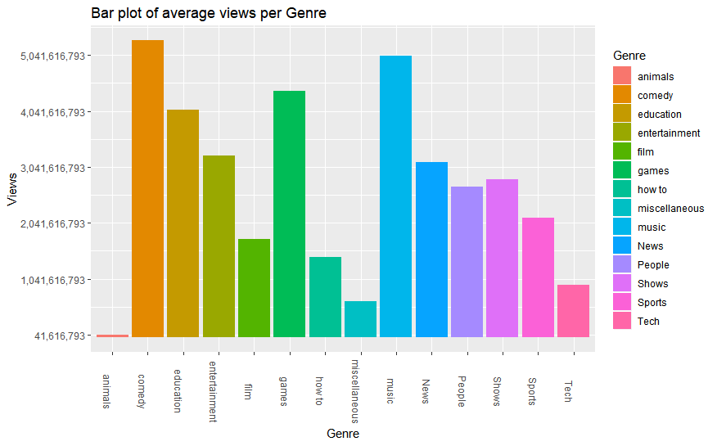

Figure above represents a bar plot of the average number of views per YouTube Genre. The bar plot above helps us identify the top YouTube Genres that have generated significant amount of views and have made these genres popular. We see that genres Comedy, Music and Games are the top three genres that have managed to attract maximum viewers where Comedy has generated approximately 5.3 billion views, Music has generated 5.04 billion views and Games genre has generated approximately 4.3 billion view. YouTube channels featuring video content in these genres are likely to gain a greater number of views and attract more users and possible subscribers than other YouTube channels featuring other genre content. The bar plot also shows us that animals genre content have generated the least number of views. This representation will help the brand advertisement teams in analyzing the different type of genres that they can consider for featuring their products for more advertisement and possible increase in sales value.

**Conclusion and Limitations**

* While performing analysis of the subscriber to views ratio, we realized that there are multiple video channels and content creators who have a large number of views but with less subscriber. This identified a section of YouTube content consumer who are anonymous and have no information based on age and subscriptions to other channels. This can be identified as an advantage to the marketing agencies since this will provide an opportunity to not only cover the target demographic group after analysis, but their products and services can also be tested with an anonymous group of consumers with more variance in demographics.
* The marketing agencies can also identify the right type of genres that they want to feature their products and services and analyze if they want to collaborate with the top YouTube channels who upload less frequectly or with channels with less subscribers but upload more frequently.
* Marketers can analyze the different parameters such as number of views, subscribers, number of likes, dislikes, their average annual salary and the demographic information based on our analysis of these parameters and their relationships with each other.
* With people having the opportunity to create their own content using the YouTube platform, sharing various experiences such as starting their own company, giving product reviews, travel vlog etc., gave a way for users from different demographic groups to connect with these content creators. And by creating content that the average population can easily connect to, these YouTubers became Influencers or YouTube celebrities.
* Some of the limitation that we analyzed in our project was with the incomplete data and limited sample size. We managed to collect a sample data of 1200 YouTube channels and hence we cannot generalize this to the entire population in the YouTube community.
* We also did not consider sentiment analysis of the parameters such as number of likes and dislikes to identify if the YouTubers are actually popular or not.
* We also did not cover the variance in the content featured in YouTube and may have missed some popular gneres. Hence more variance in the dataset and a large sample size would have made the data more reliable.

References:

* [Michelle Krasniak](https://www.socialmediaexaminer.com/author/michelle-krasniak/), 2017. YouTube Advertising: New Research and Insights for Marketers. Retrieved from: <https://www.socialmediaexaminer.com/youtube-advertising-research-insights-marketers/>. Accessed on 2nd Oct 2018.
* Jung Ung Lee, 2018. YouTube vloggers' influence on consumer luxury brand perceptions and intentions.<https://www.sciencedirect.com/science/article/pii/S0148296316304222>. Accessed on 2nd Oct 2018.
* Wilma Westenberg, 2016. The influence of YouTubers on teenagers, University of Twente. Retrieved from: <https://essay.utwente.nl/71094/1/Westenberg_MA_BMS.pdf>.
* Forbes, 2017. 5 Tips to Improve Your YouTube Marketing Strategy. https://www.forbes.com/sites/ajagrawal/2017/01/12/5-tips-to-improve-your-youtube-marketing-strategy/#40c98c56494f. Accessed on 3rd Oct 2018.
* YouTube: Analytics and Reporting APIs (2018). *Retrieve viewing statistics, popularity metrics, and more for YouTube videos and channels.* Retrieved from <https://developers.google.com/youtube/analytics> . Accessed on November 1, 2018.
* Influencer Marketing Hub, 2016. *YouTube Money Calculator*. Retrieved from <https://influencermarketinghub.com/youtube-money-calculator/> . Accessed on November 5,2018.
* Google APIs Terms of Service (2014). *Section 2: Using Our APIs*. Retrieved from <https://developers.google.com/terms/#section_2_using_our_apis> . Accessed on November 5, 2018.